

SISTEMA INTEGRADO DE TELEMETRÍA Y ANALÍTICA AGRÍCOLA CON DRONES
CONSOLIDADO DE TALLERES (WORKSHOPS 1, 2 Y 3)

INTEGRANTES (GRUPO 7):
JAMER ANDRÉS TAPIAS MORENO
SERGIO NICOLÁS RODRÍGUEZ FERNÁNDEZ
CARLOS MARIO MANCO TUBERQUIA

PROFESOR:
WILLIAN CORNEJO

ASIGNATURA:
LÓGICA Y REPRESENTACIÓN III

UNIVERSIDAD DE ANTIOQUIA

FACULTAD DE INGENIERÍA

PROGRAMA DE INGENIERÍA DE SISTEMAS

2026
CONSOLIDATED ANALYSIS REPORT: PRECISION AGRICULTURE DRONE MONITORING
Group: 7 Units 1, 2 & 3
Domain: Autonomous Drone Telemetry & Crop Health Analytics
1. Scenario Recap & System Architecture
Modern precision agriculture relies on autonomous drone fleets continuously collecting high-frequency telemetry data across multiple crop fields (Field_A to Field_J / FIELD-01 to FIELD-10). The telemetry payload includes key health metrics: ndvi_index, soil_moisture, battery_pct, stream_seq, and spatial transit records.
Processing raw telemetry post-mission introduces critical operational latency. To enable immediate crop-stress mitigation, our architecture integrates:
- Big Data Storage & Load Balancing (Unit 1): Universal Hashing and Power-of-Two-Choices load balancing.
- Stream Processing Algorithms (Unit 2): Low-memory probabilistic data structures (Bloom Filters, Reservoir Sampling, Flajolet-Martin).
- Graph Topology & Markovian Modeling (Unit 3): Discrete-Time Markov Chains (DTMC), Stationary Distribution ($π$), Standard PageRank overlaid with NDVI, and Monte Carlo Lazy Random Walk simulations.
2. Unit 1: Big Data Context, Universal Hashing & Load Balancing
Empirical Results & Performance
- Big Data Ingestion Scale: A baseline fleet of 50 farms generates 500req/s (2.68 GB/day). Scaling 10 x (500 farms) increases throughput linearly to 5,000 req/s (26.82 GB/day $≈$9.56 TB year), mandating scalable routing and index lookup.
- Reservoir Sampling (k = 1,000): Uniform random sampling over 10,000 records executed in t < 10 ms, estimating field-level average NDVI with a marginal Mean Absolute Error (MAE) of 0.035.
- Universal Hashing (m = 100,000, p = 1,000,003): Direct key-based indexing achieved O(1) average lookup time ($\sim$1.31ms per query) with negligible collision rates.
- Drone-ID Bucketing: Comparing load distribution across 20 buckets (5 drone IDs):
  - Standard Chaining: Runtime = 0.0267 s, Load Standard Deviation = 866.15.
  - Power-of-Two-Choices: Runtime = 0.0495 s, Load Standard Deviation = 564.19 (a 34.8% reduction in peak bucket load variance).

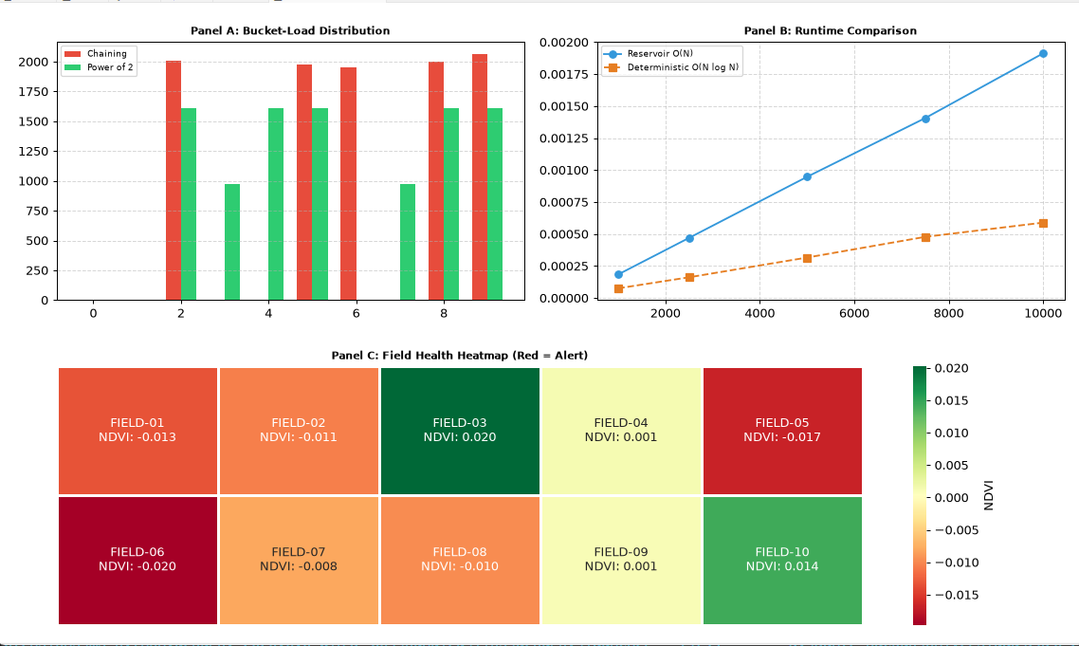
3. Unit 2: Real-Time Data Stream Processing
Empirical Results & Performance
- Stream Model & Query Design (Task 1): Standing query maintains a rolling average of ndvi_index over the last 200 stream readings per field. Ad-hoc query identified 7 active unique fields surveyed on the target date.
- Bloom Filter (Task 2): Configured with bit-array size m = 62 bits and k = 4 hash functions. Blocks duplicate health alert dispatches. Theoretical false-positive rate: 5.11%; empirical false-positive rate: 0.00% (0/1).
- Reservoir Sampling S3 (Task 3): Evaluated over 10,000 telemetry records across distinct sample sizes k $∈$ $\left\{100, 500, 1000\right\}$:
  - True Stream Averages: NDVI = 0.0078, Soil Moisture = 27.6077%.
  - k = 100: Estimated NDVI = -0.0727 (Abs. Error: 0.0805).
  - k = 500: Estimated NDVI = 0.0489 (Abs. Error: 0.0411).
  - k = 1000: Estimated NDVI = 0.0439 (Abs. Error: 0.0361).
- Flajolet-Martin Distinct Count (Task 4): Probabilistic cardinality estimation using 10 hash functions yielded an exact estimate of 10 unique fields (Ground Truth = 10, 0.00% relative error).
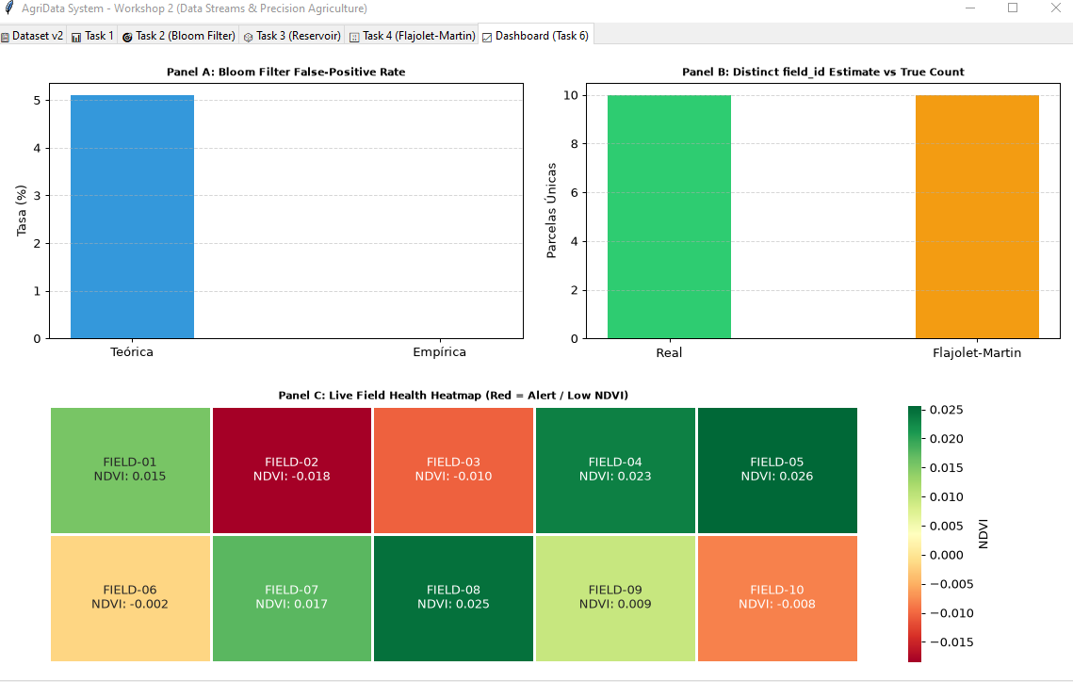
4. Unit 3: Markov Chains & Graph Topology Analysis
Empirical Results & Performance
- DTMC & State Classification (Task 1): Row-normalized adjacency transition matrix M classified 10 fields based on traffic volume relative to the system median:
  - Recurrent / Hub Fields (5): Field_A, Field_B, Field_C, Field_F, Field_J.
  - Transient / Peripheral Fields (5): Field_D, Field_E, Field_G, Field_H, Field_I.
- Stationary Distribution $π$ (Task 2): Highlights structural centrality over raw flight volume. Field_D holds only 6.74% of raw flight traffic but scales to $π$ D = 16.81% due to its high topological role as a network connector.
- PageRank & Critical Crop Health Alerts (Task 3): Overlaying Standard PageRank structural scores with field health (ndvi_ index < 0.55) highlighted 3 priority intervention candidates:
  - Field_C: PageRank Rank 1 (Score 0.169) | Raw Flight Rank 3 | NDVI = 0.431.
  - Field_F: PageRank Rank 3 (Score 0.130) | Raw Flight Rank 5 | NDVI = 0.407.
  - Field_I: PageRank Rank 6 (Score 0.104) | Raw Flight Rank 10 | NDVI = 0.447.
- Lazy Random Walk Monte Carlo Simulation (Task 4): Simulated over 50,000 steps (p_{self-loop} = 0.5). Empirical visit distribution converged to analytical $π$_{lazy} with a maximum absolute error of 0.00216 (Field_I) and minimum of 0.00004 (Field_E), confirming system ergodicity.

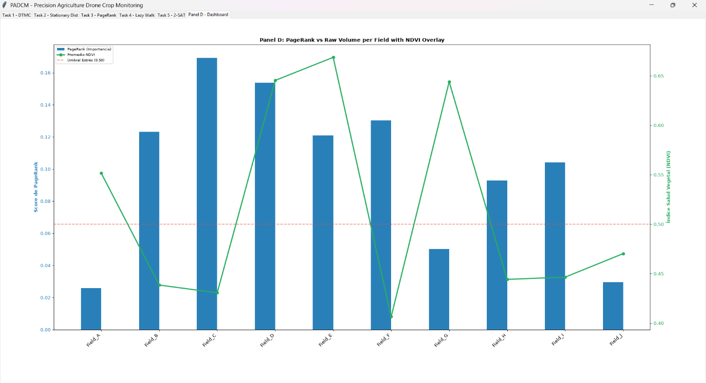5. Summary Matrix: Theoretical vs. Empirical Comparison
Module / Algorithm | Theoretical Complexity | Observed Empirical Performance | Validation
Reservoir Sampling | O(N)time,  O(k) space | Executed in t < 10 ms for 10,000 items (MAE $≤$0.036) | Validated
Universal Hashing | O(1) avg search time | 1.31 ms avg query time with near-zero collisions | Validated
Power-of-Two-Choices | Max Load O(log log n) | Standard deviation reduced from 866.15 to 564.19 | Validated
Bloom Filter | O(k) lookup,  O(m) space | 0.00% empirical false positives (vs 5.11% theoretical limit) | Validated
Flajolet-Martin | O(N) time, O(log log N) space | Estimated 10 unique fields with 0.00% relative error | Validated
DTMC & PageRank | Stationary vector $π$M = $π$ | Successfully detected critical sub-monitored fields (Field_C, F, I) | Validated
Lazy Random Walk | Monte Carlo Ergodic Convergence | Max error vs analytical $π$: 0.00216 (< 0.22%) | Validated
6. Integrated System Conclusions
- Memory Efficiency: Probabilistic streaming algorithms reduce memory footprint from O(N) to O(k) or O(log log N), enabling real-time telemetry processing at zero storage-overhead.
- Load Distribution Optimization: Combining Universal Hashing with Power-of-Two-Choices mitigates system bottlenecks in high-throughput drone ingest pipelines.
- Graph-Centric Stress Detection: Markov Chains and PageRank provide far deeper operational insight than raw flight counts, revealing structural fields (like Field_C and Field_D) that warrant immediate agronomic intervention.

